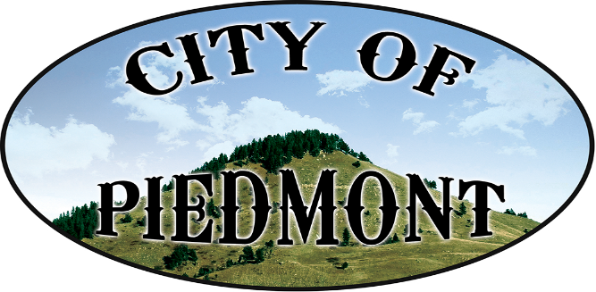
\

111 2nd St. PO Box 101, Piedmont, SD /Piedmont1@rushmore.com/piedmontsd.com
Phone 605-716-5495/Fax 605-716-6013

Resolution 2017-03

Whereas: Mary Wilson has been involved in Girl Scouts as a youth, and as an adult for 65 years, serving in multiple local and national leadership positions, and received numerous awards, including the Juliette Gordon Lowe World Friendship Medal, and

Whereas: Mary Wilson has served in a variety of capacities in the Piedmont Valley, including working as an Election Worker, serving on the Piedmont Cemetery Board, and being involved in the Happy Ten Sewing Club, and

Whereas: Mary Wilson has been an active member of Grace United Methodist Church, offering her gifts and putting her faith into action in a host of ways, including serving on the Memorial Committee, and faithfully playing the church organ for 50 years, and

Whereas: Mary Wilson has taught countless children as an elementary school teacher, teaching 4 years in Wall and 19 years in Piedmont, and

Whereas: Mary Wilson, and her beloved late husband Jack, have lived and worked in the community, building friendships, creating livelihood, and giving back.

Be it Resolved by the Board of Trustees of the City of Piedmont, at their
meeting on April 4th, 2017, by a unanimous vote, do hereby declare
April 9th, 2017
as
Mary Wilson Day
in the City of Piedmont

Signed (SEAL)

_______________________________
Philip C. Anderson
Piedmont, Board President _______________________________
Diana L. Evans, Finance Officer
Published: April 19, 2017
Effective: April May 8, 2017
This institution is an equal opportunity provider.

