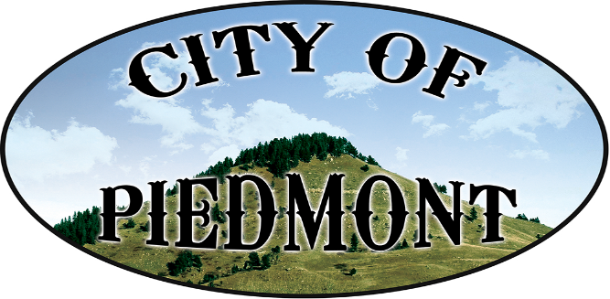
\

111 2nd St. PO Box 101, Piedmont, SD /Piedmont1@rushmore.com/piedmontsd.com
Phone 605-716-5495/Fax 605-716-6013

Resolution 2017-02

Whereas: Anna Marie Thatcher has been instrumental in helping the Piedmont
Valley Library Friends Group obtain the status as a 501(c)(3) as she volunteered many hours assisting the group in writing the documents to meet the criteria of the IRS, and

Whereas: Graham Thatcher recently offered an interesting program on the Arts,
and donated copies of his book “I know what I like!: Everyone’s Guide to the Arts” to the Library and general public, and

Whereas: Anna Marie and Graham have been avid supporters of our Library with many generous donations, and

Whereas: On February 15th, 2017, Anna Marie & Graham Thatcher received the Governor’s Award for Outstanding Support of the Arts in South Dakota.

Be it Resolved by the Board of Trustees of the City of Piedmont, at their
meeting on February 21st, 2017, by a unanimous vote, do hereby declare

February 26th, 2017
as
Anna Marie and Graham Thatcher Day
in the City of Piedmont

Signed (SEAL)

_______________________________
Philip C. Anderson
Piedmont, Board President _______________________________
Diana L. Evans, Finance Officer

Published: March 1, 2017
Effective: March 20, 2017

This institution is an equal opportunity provider.

